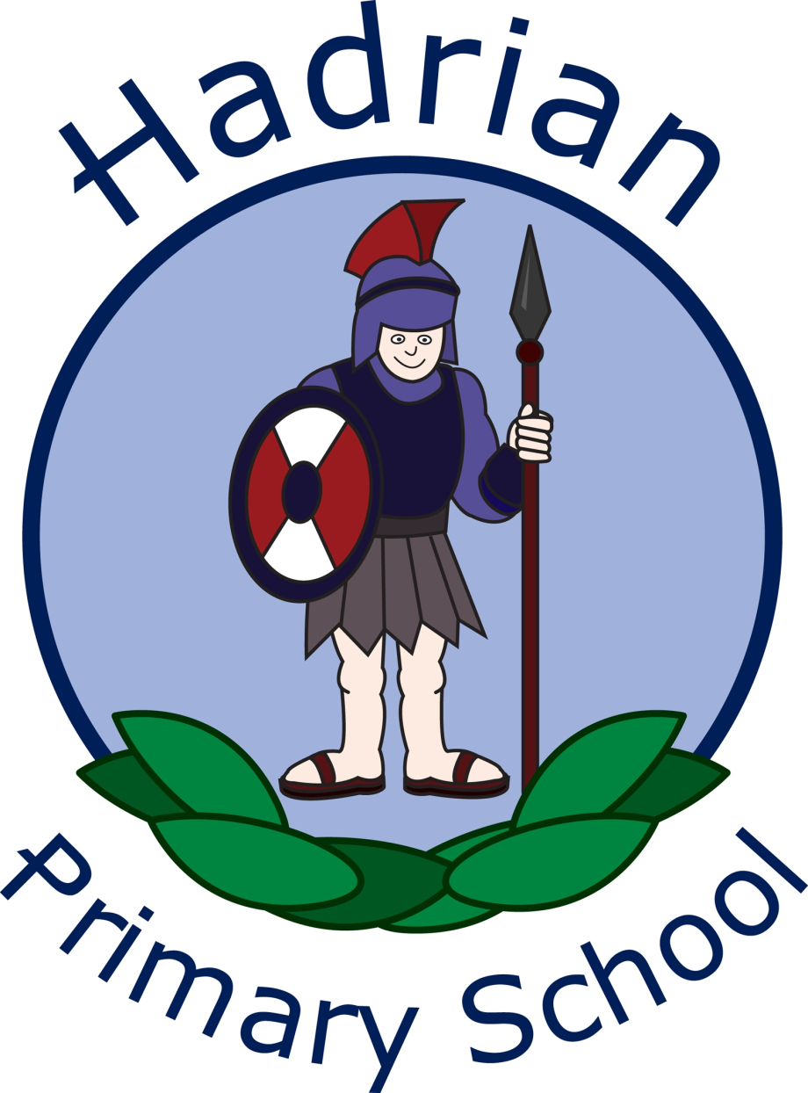

Hadrian Primary School
Handwriting and Presentation Policy
October 2026

Staff responsible:

Mr S Brown-Head Teacher

Miss J Pattison-Deputy Head Teacher

Mrs S Stout- English Lead

Handwriting and Presentation Policy

This policy reflects the Department for Education Writing Framework (2025), the National Curriculum in England and the EYFS statutory framework. Letter-Join is the school’s chosen teaching resource; the WISE Academies Early Years Writing Continuum supports developmental progression in Nursery and Reception.

At Hadrian Primary School, the Handwriting and Presentation Policy is designed to facilitate a culture of pride and excellence in the written work of all pupils. Recognising the fundamental importance of effective handwriting skills as outlined in the National Curriculum, we aim to equip our pupils with the ability to communicate their thoughts clearly and legibly. A coherent and aesthetically-pleasing presentation enhances the quality of work, alongside instilling a sense of accomplishment and pride in our learners. Our policy emphasises the significance of accurate letter formation, handwriting fluency and the appropriate development of joining using the Letter-Join handwriting scheme, ensuring that pupils consistently express their ideas with clarity and confidence. By adhering to structured guidelines and practising regularly, we aspire to cultivate a generation of thoughtful individuals who take pride in their presentation, reflecting the high standards we uphold throughout our school.

Aims
Handwriting is a foundational transcription skill. As letter formation becomes accurate and automatic, pupils can devote more attention to spelling, sentence construction and composition. Teaching prioritises secure foundations over premature demands for lengthy written outcomes.
- The primary aim of our handwriting and presentation policy is to cultivate a neat, legible, and speedy handwriting style amongst our pupils.
- We endeavour for children to develop automaticity in their writing through the consistent use of the Letter-Join scheme, enhancing fluency during independent writing tasks.
- Our policy advocates for a consistent approach across all year groups, prioritising legibility, fluency and automaticity. Pupils learn to join letters when unjoined formation is secure and appropriate to their stage of development.
- All adults within the educational setting are expected to adopt a common methodology when modelling handwriting to children.
- By fostering a dedicated environment focused on these principles, we aim to support our pupils in becoming confident and proficient writers.

Expectations

All staff are expected to model the printed or cursive style of handwriting appropriate to each year group as set out in the Letter-Join scheme. Pupils should experience coherence and continuity in the learning and teaching of handwriting across school, and be encouraged to take pride in the presentation of their work. Our objective is to help pupils enjoy learning and developing their handwriting, with a sense of achievement and pride. Letter families and terminology are introduced within Early Years: Curly Caterpillars, One-Armed Robots, Long Ladders and Zigzags (see Appendix A).

Handwriting and Presentation Guidance

A consistent approach to handwriting and presentation is adopted and reinforced in every classroom. Handwriting is taught explicitly in short, focused daily sessions, with further supervised practice and application across the curriculum. Teachers model correct formation, provide guided practice and immediate feedback, and revisit skills until letter formation becomes accurate, fluent and automatic. The length and content of sessions are adapted to pupils’ age and stage.

Handwriting

Early Years

The WISE Academies Writing Continuum informs progression in the foundational skills for transcription across two-year-old provision, Nursery and Reception. Staff use the continuum alongside Hadrian’s developmental assessment tools to plan opportunities for gross-motor and core strength, bilateral integration, hand–eye coordination, fine-motor precision, pencil control and pressure, and pre-writing shapes. Children are supported through purposeful indoor and outdoor provision, direct modelling and responsive assessment. These preparatory experiences complement, rather than replace, explicit teaching of accurate letter formation in Reception. The supporting progression guides, assessment tools and activity resources are included in Appendices D–K.

Practitioners use observations, examples of children’s mark-making and writing, and the school’s fine-motor and developmental assessment tools to identify individual starting points, recognise barriers and review progress over time. Assessment findings inform adjustments to continuous provision, focused adult modelling and short, targeted opportunities for children who need additional practice, including in core stability, bilateral coordination, hand–eye coordination, pencil control or letter formation. Staff review the impact of this support and adapt the next steps accordingly, while maintaining ambitious, developmentally appropriate expectations for every child. In Reception, the WISE Academies Reception Writing Tracker is used alongside these tools to monitor progression from purposeful mark-making and phoneme–grapheme correspondence to writing dictated words, captions, phrases and sentences. Staff use the tracker to identify children requiring additional modelling or practice, inform phonics-aligned writing opportunities and review the impact of targeted support (see Appendix K).

In Nursery, children take part in daily, developmentally appropriate handwriting-readiness sessions that develop the physical and perceptual foundations for writing, alongside purposeful provision. In Reception, children receive daily, direct and systematic handwriting sessions, with opportunities to apply their developing transcription skills in phonics and writing.

Sessions include:

- Squiggle While You Wiggle which focuses on large movements to enhance gross motor skills such as; air-writing, pattern making (to follow patterns on Letter-Join) and dancing.
- Flying With Formation which encourages fine and gross motor pre-writing skills.
- Dough Disco which strengthens hand muscles in readiness to write.
- Exercises to develop fine motor skills such as; making marks on paper, whiteboards, blackboards, sand trays and iPads.
- Recognising letter shapes and correct formation using letter families.
- Correct sitting position (see appendix B) and pencil grip (See appendix C) for handwriting.
- Reception children follow Letter-Join Print Plus for explicit teaching of accurate, unjoined letter formation, coordinated with the graphemes taught through Sounds-Write where appropriate.

Letter-Join Module 1 Print: Early Years provides printed-letter formation, pre-writing patterns and motor-skills activities that support the school’s Print Plus approach. In Reception, teachers prioritise accurate, unjoined letter formation and use relevant Module 1 resources to reinforce this teaching.

It is divided into three sections covering:
- Pre-Writing Patterns
- Easy Letters and Words
- Harder Letters and Words
Upon completion of this module, children should be able to recognise and form all of the printed, lowercase letters of the alphabet.
Please see Appendices D–K for the Early Years progression and assessment resources.
Key Stage 1

In Key Stage 1, handwriting is taught daily through short, focused sessions, with ongoing reinforcement in writing across the curriculum. Children first learn to form lowercase letters, capitals and digits accurately, with appropriate size, orientation and spacing. Once unjoined letters are secure, teachers explicitly introduce appropriate diagonal and horizontal joining strokes, including which letters are best left unjoined. Letter-Join materials are selected to support this sequence; lead-in strokes are not a prerequisite for successful handwriting.
Teachers identify handwriting difficulties early and respond with additional explicit modelling, closely supervised practice and small, achievable steps. Left-handed pupils receive appropriate positioning and paper-angle guidance. Reasonable adjustments and specialist advice are considered where physical, sensory or motor needs affect transcription. Handwriting practice is not used as a barrier to pupils demonstrating their ideas orally or through appropriate alternative recording methods.

- Children will follow Letter Join Print Plus to develop their handwriting
- Gross and fine motor skills exercises
- Handwriting reinforcement, learning and practice
- Numerals, capitals and printed letters; where and when to use, learning and practice
- KS1 SATs SPaG exercises
- Progression to joining is determined by secure, consistent letter formation and readiness, not by greater-depth attainment alone.

Letter-Join Module 2 Print to Cursive teaches how to correctly write capital letters, uses of printed letters, numbers, punctuation, mathematical symbols and other symbols. Pre-cursive patterns and cursive letters are then introduced in preparation for Module 3, where children are required to start joining their handwriting.
The descriptions of Letter-Join Modules 2 and 3 outline the resources available. At Hadrian, teachers select activities according to pupils’ readiness: secure unjoined letter formation comes first, and joining is introduced explicitly only when appropriate. Lead-in strokes are not required before pupils learn to join.
It is divided into three sections covering:
- warm-ups, letter families and capital letters
- uses of printed letters
- numbers and symbols
- introducing pre-cursive patterns and cursive letters
On finishing this module, children should be confident in writing all the capital and printed letters, numbers and symbols and start to become familiar with the orientation of cursive letters.
Letter-Join Module 3 Starting Cursive introduces children to cursive letters and how to join them. They will have regular practise in letter formation and joining their handwriting.
The sections in this module cover:
- Cursive letters and words
- Letter families
- High frequency words
- Joining techniques
- Sequencing sentences
- Dictation exercises
- Times table facts
- SPaG practice for KS1 SATs
With the regular handwriting practice throughout this module, children should now be developing the fluency and speed of their writing.

Key Stage 2
In Key Stage 2, all classes receive daily, explicit handwriting teaching through short, focused sessions, alongside opportunities to practise and apply these skills across the curriculum. Pupils who have not yet developed fluent, legible handwriting receive additional targeted instruction and practice.

- Children will follow Letter-Join No-lead to develop and reinforce their cursive handwriting style.
- Opportunities to support automaticity to demonstrate legible, fluent, cursive handwriting with increasing speed.

Lower Key Stage 2: Years 3 and 4

Year 3 Letter-Join Module 4 is targeted at children in lower KS2 where pupils should be using a cursive style throughout their independent writing in all subjects, helping to refine their handwriting in line with the requirements of each lesson. This module covers topics such as dictation, double letters, number vocabulary, palindromes, tongue twisters, MFL (French and Spanish), onomatopoeia, simile and statutory spellings.

Completion of Module 4 should ensure improvement in the legibility, consistency and quality of the children’s handwriting through a variety of resources which link handwriting to other areas of the curriculum.

Year 4 Letter-Join Module 5 focuses on using handwriting practice to support other subjects in the curriculum and, at the same time, builds on fluency and consistency. This module aims to promote meaningful links with other subjects such as English, maths, science, geography and Spanish. Making such links enables children to apply the skills they are learning in context and also provides depth to the curriculum.

Learners will continue to build on producing fluent, consistent and legible handwriting through daily focused handwriting sessions using this module’s lessons and resources.
On concluding this module, children will have practised applying size-appropriate handwriting to all areas of the curriculum whilst maintaining fluency and legibility.

Upper Key Stage 2: Years 5 and 6
In Years 5 and 6, pupils receive daily, focused handwriting sessions, alongside opportunities to practise and apply their skills across the curriculum. Pupils who have not secured accurate, fluent and automatic handwriting receive additional explicit instruction and targeted practice.
More advanced handwriting techniques will be taught and consolidated through daily handwriting sessions:

- Dictation exercises promoting quick note-taking, handwriting speed and fluency
- KS2 SATs SPaG practice

Year 5 Letter-Join Module 6 continues to build on combining fluent handwriting with other subjects across the curriculum.

In this module, learners will have plenty of opportunity to develop the stamina and skills to write at length, with accurate spelling and punctuation. With Letter-join’s wide range of resources they will be able to work towards producing consistently neat and well-presented handwriting in all curriculum subjects.

On completing this module, children should be producing cursive writing automatically, enabling them to focus on the content of their work rather than the process of writing.

Year 6 Letter-Join Module 7 presents learners with a range of tasks where they have to decide on an appropriate style of handwriting. Promoting speedy, fluent writing continues to be a strong feature. Challenging dictation exercises will refine pupils’ revising and checking skills as well as boosting their handwriting speed, stamina and fluency. A range of curriculum-based worksheets will give pupils the opportunity to practise writing at length.
Module 7 also contains a series of worksheets to aid KS2 SATs SPaG revision. They are designed to support year 6 pupils in meeting expected standards for spelling, punctuation and grammar, with lots of SPaG preparation and plenty of handwriting practice.
By the end of this module, children should be able to adapt their handwriting for a range of tasks and purposes and to create different effects. They should be clear about what standard of handwriting is appropriate for a particular task, e.g., quick notes or a final handwritten version.

Staff should model handwriting appropriate to the year group taught at all times.

Presentation

Children in all year groups will use a pencil in maths. Pencils will be used for drawings and for the completion of diagrams and graphs. Mistakes and errors can be rubbed out completely or should be crossed out with one horizontal ruled line.

Early Years:
- Work should be dated by the teacher using the short date at the top of the page.

Year One:
- Children should write the short date (14.10.26) in all pieces of work and a short title where appropriate.
- Labels should be used to indicate learning objectives
- Children use the second line in their books for writing any dates/titles to reinforce correct letter sizing.
- Children will prepare for transitioning to Year 2, writing the long date and title (learning objective) in Summer 2.

Year Two onwards:
English and other written work

- DUM TUMS (Date, Underline, Miss a line, Title (learning objective), Underline, Miss a line, Start) will be used from Year Two onwards.
- Year Two children will use the second line in their books for writing any dates/titles to reinforce correct letter sizing.
- The long date must be written in the following way: Wednesday 14th October 2026.
- The date and learning objective (when appropriate) should be underlined once using a ruler.
- A new paragraph should be indicated by missing a line.
- If work is continued in another lesson, children should continue from where they left off and write the short date in the margin (14.10.26).
Maths
- Pencils must be used throughout school in maths.
- One digit should be written in each box.
- The short date should be written in the top right corner in the following way: 14.10.26
Materials
Pencils are used while children establish a comfortable, controlled and legible handwriting style. From Year 3, pupils may be awarded a pen licence when they demonstrate consistent control, legibility and readiness; a fully joined style is not the sole criterion. Pencils continue to be used for mathematics, diagrams and drawings.

Year group handwriting checklists support consistent assessment of letter formation, spacing, legibility, fluency and automaticity from Reception to Year 6. Teachers use them alongside pupils’ work and direct observation to identify next steps, plan additional explicit instruction and review progress. The checklists describe a progression of skills rather than rigid age-related pass-or-fail criteria. Children secure accurate letter formation before learning joins, and pupils who need more time receive appropriately sequenced support. The Reception to Year 6 handwriting progression checklists are published separately on the school website and are used by staff to support assessment, planning and progression. The WISE Academies Reception Writing Tracker (Appendix K) continues to assess broader early writing development.

Handwriting Assessment and Progression

Monitoring and evaluation consider the accuracy of letter formation, orientation, spacing, fluency and ease of writing, as well as presentation. Senior leaders and the English Lead review the consistency of daily teaching and staff modelling, pupils’ progress (including those receiving additional support), and the impact of transcription on independent composition. Evidence includes lesson visits, work scrutiny, pupil discussions and brief handwriting samples. Class teachers uphold consistent expectations across subjects; the English Lead evaluates the effectiveness of the policy as part of the review cycle.
Appendix B: Correct posture/grip
Appendix A: Letter Formation Families
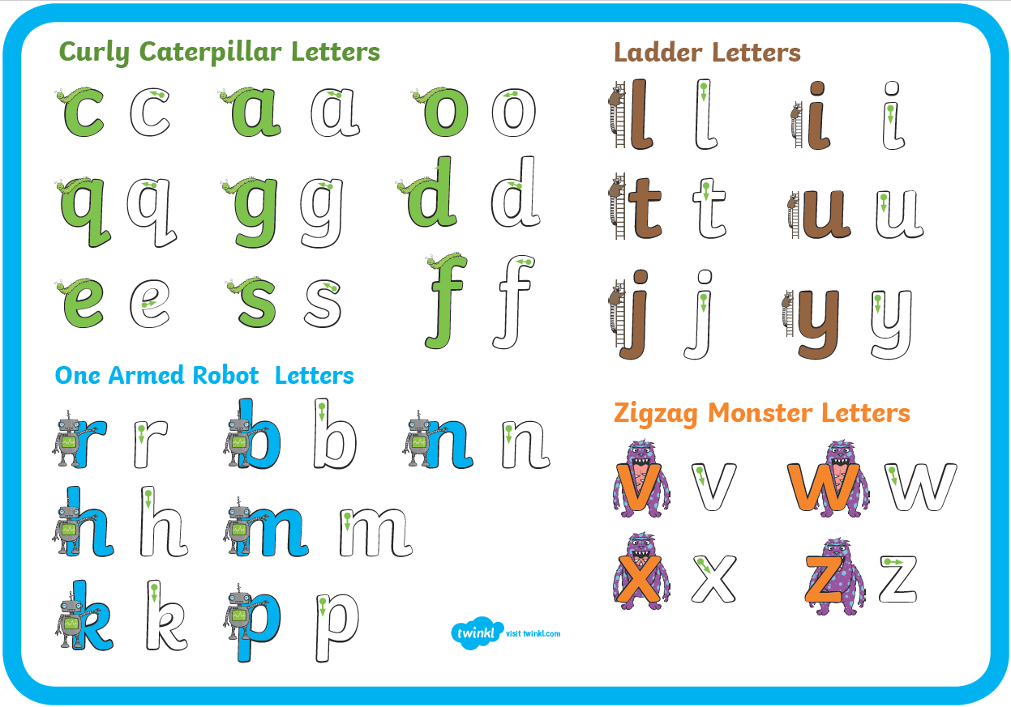
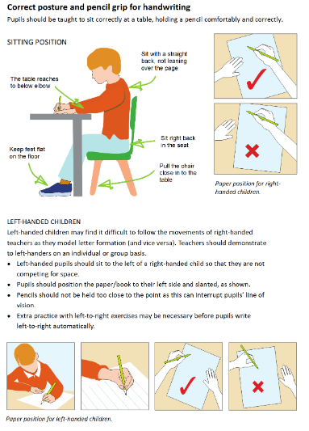

Appendix C: Tripod Pencil Grip
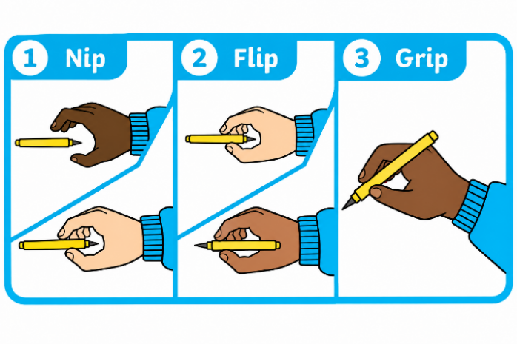

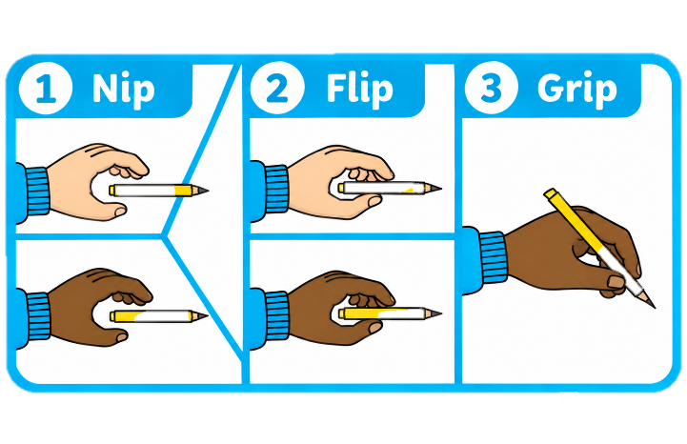

Appendix D: Pre-requisite Skills for Writing: EYFS
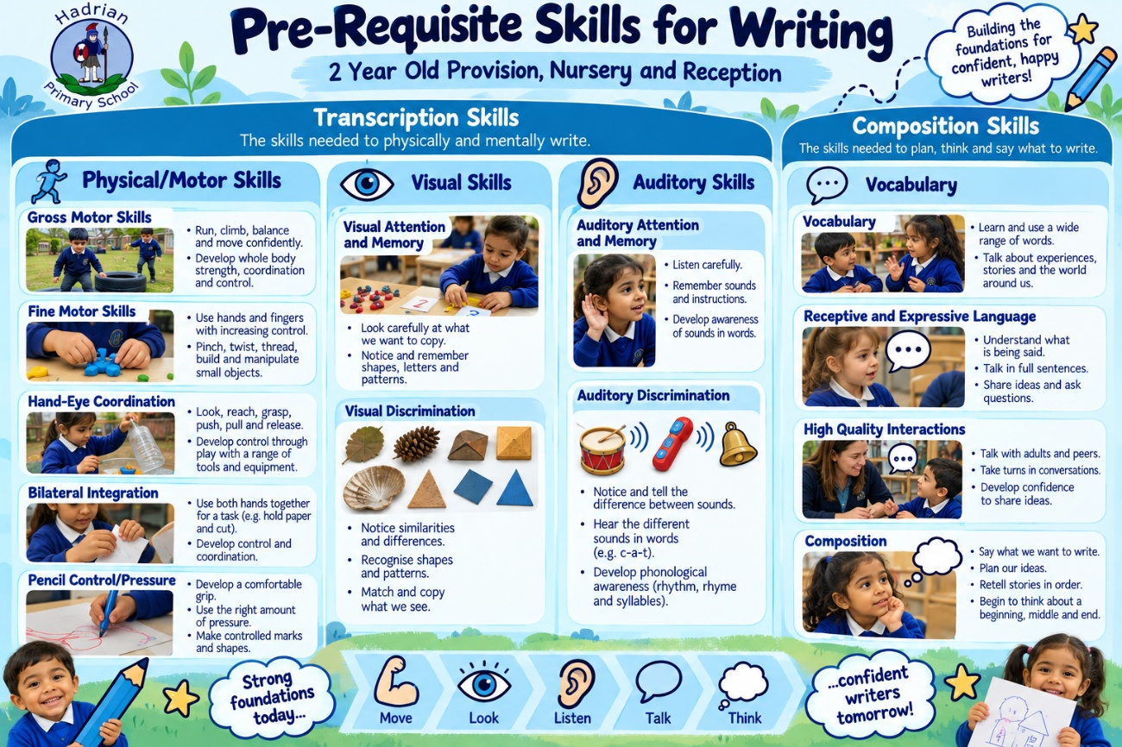

Appendix E: Pre-requisite Skills for Writing: Progression
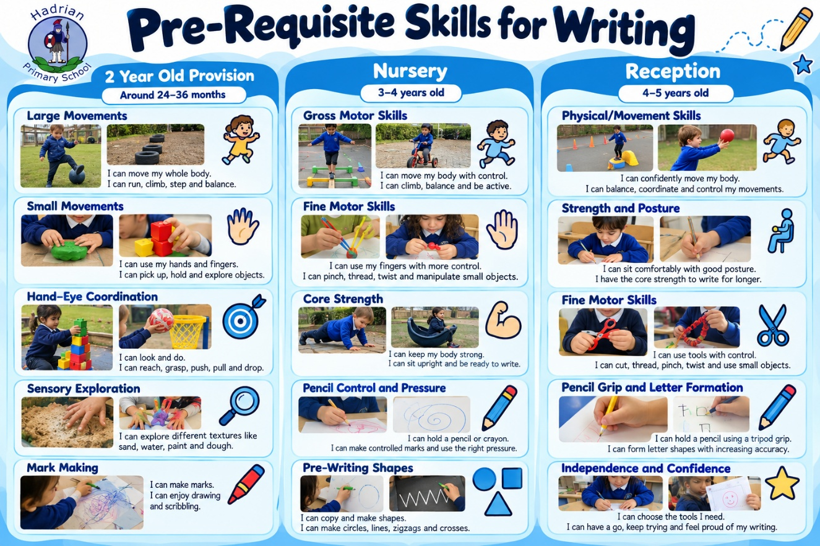

Appendix F: Foundational Knowledge at Hadrian EYFS
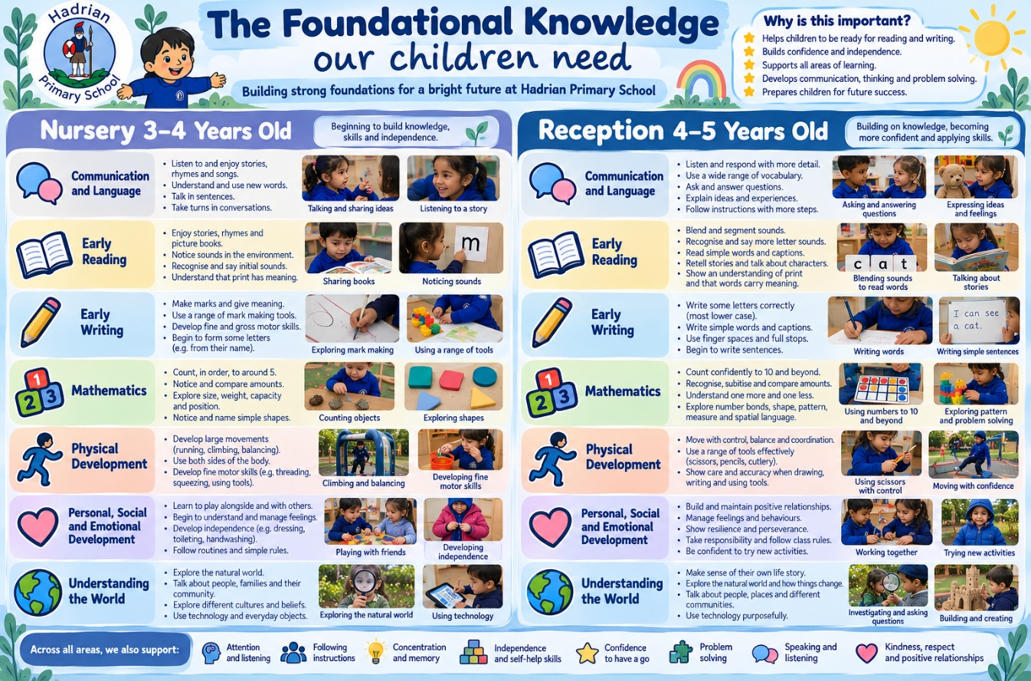

Appendix G: Developing Bilateral Integration and Crossing the Midline
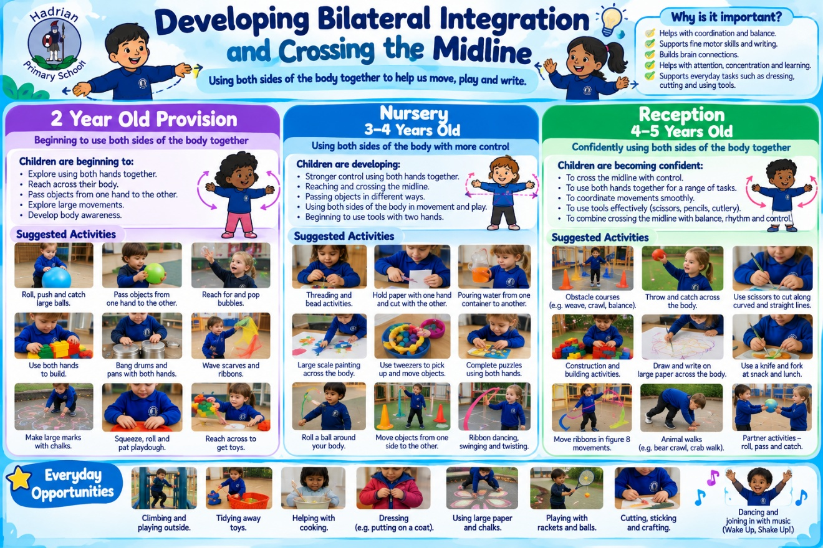

Appendix H: Hadrian Early Years Assessment Tools

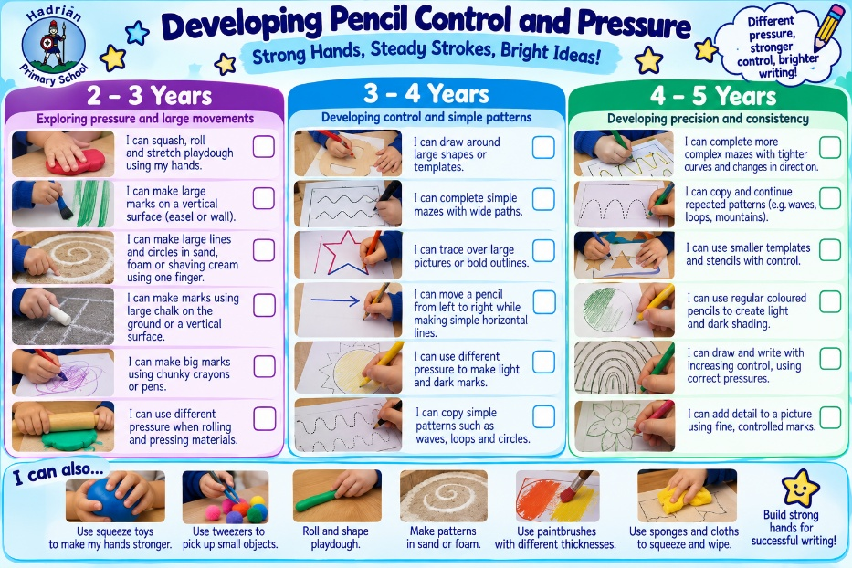
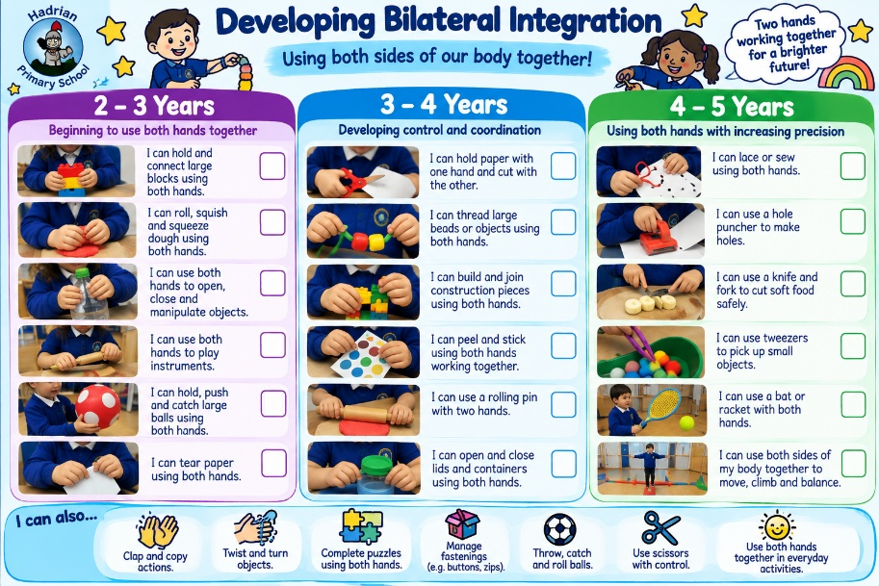
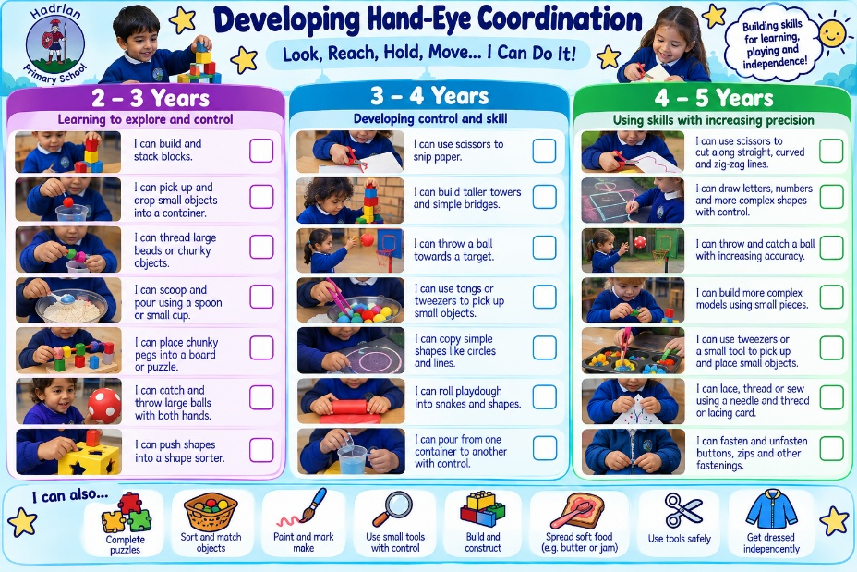
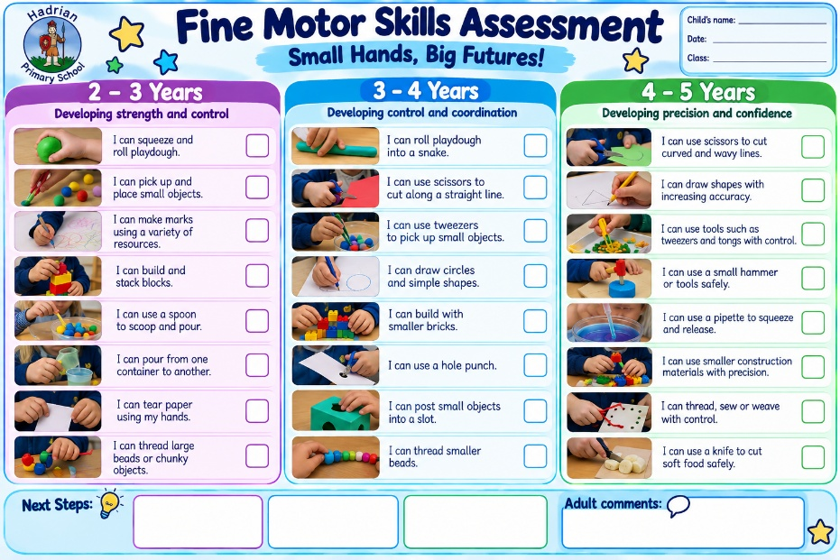
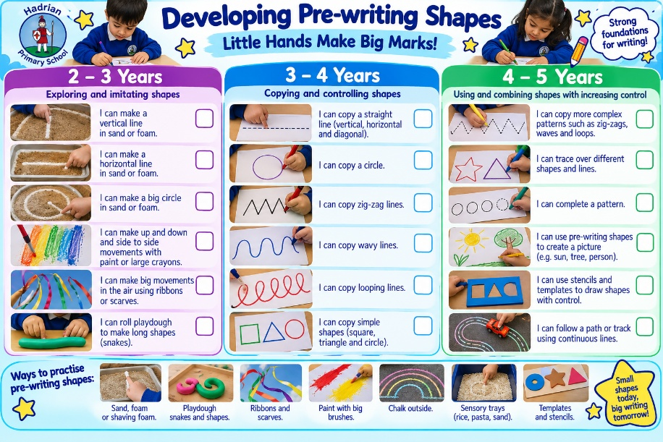

Appendix I: Name Writing Progression
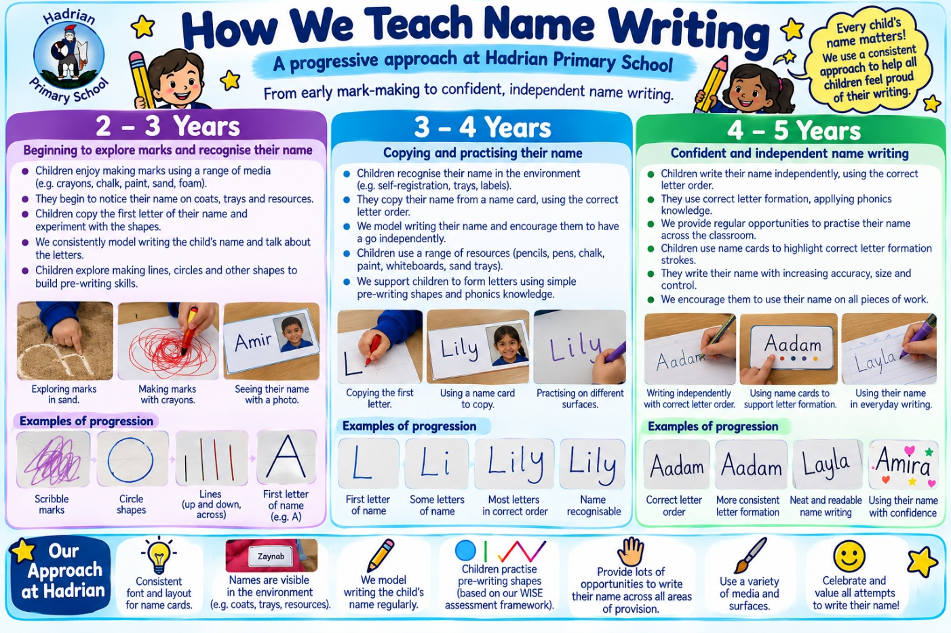

Appendix J: Outdoor Gross Motor and Core Strength Activities

All outdoor activities must be age-appropriate, supervised and subject to the school’s relevant risk assessments. Equipment, loads and levels of challenge should be adapted to individual children’s needs.

1. Heavy Work & Resistance Play
Activities involving pushing, pulling, lifting and carrying build functional core stability, upper-body power, and proprioceptive awareness.
Tyre Pulling: Attach heavy ropes to tyres for children to drag across grass or tarmac.
Crate Rides: Pull peers seated safely inside sturdy milk or bread crates.
Wheelbarrow Runs: Transport soil, sand, water or loose parts across the outdoor area.
Large-Scale Loose Parts: Lift, carry, and manoeuvre heavy crates, wooden planks and tyres to build structures.
Full-Body Cleaning: Sweep large areas using stiff outdoor brooms or scrub outdoor windows using squeegees and buckets.

2. Climbing, Hanging & Upper-Body Strength
Hanging and climbing movements build grip strength, shoulder stability and postural core control.
Monkey Bars: Progress from hanging/swinging to full traversal.
Climbing Frames & Walls: Vertical and lateral climbing to target core stabilisation.
Ladder Navigation: Climb up and down leaning or fixed ladders as part of play structures.
Hills & Earth Mounds: Run, scramble and roll up and down natural gradients.

3. Dynamic Obstacle Courses & Balance
Changing levels, dynamic surfaces, and direction shifts engage core stabilisers and balance systems.
Chalked Movement Trails: Simple, low-resource chalk paths incorporating jumping targets, zigzag lines and spin spots.
Stepping Stones & Tyres: Stepping between stone markers or stepping in and out of tyre centres.
Balance Beams & Planks: Traversing raised or narrow surfaces.
Tunnels & Crawling Trails: Low-clearance crawling obstacles that target core-to-limb coordination.
Stilts: Bucket or wooden stilts to challenge postural control and rhythm.

4. Gross Motor Construction & Sensory Play
High-engagement outdoor areas that combine heavy movement with imaginative play.
Large-Scale Sandpit & Mud Kitchen: Digging, shovelling and lifting heavy wet sand or mud.
Block Building: Transporting and stacking large wooden or foam construction blocks.
Water Transporting: Filling, carrying and tipping heavy water trays, buckets and water-channelling pipes.
Forest School Sessions: Navigating uneven natural terrain, climbing low branches and carrying logs or branches.

5. Locomotion, Coordination & Target Play
Activities targeting spatial awareness, bilateral coordination and rotational core strength.
Wheeled Vehicles: Riding balance bikes, pedal bicycles, scooters and pedal cars.
Hula Hoops: Spinning, jumping through or rolling hoops.
Throwing & Aiming: Beanbag tosses, ball catching and target rolling.
Large Wall Painting/Mark-Making: Using large emulsion brushes and water to paint broad strokes on walls and floors, promoting cross-midline movements.

Appendix K: WISE Academies Reception Writing Tracker


