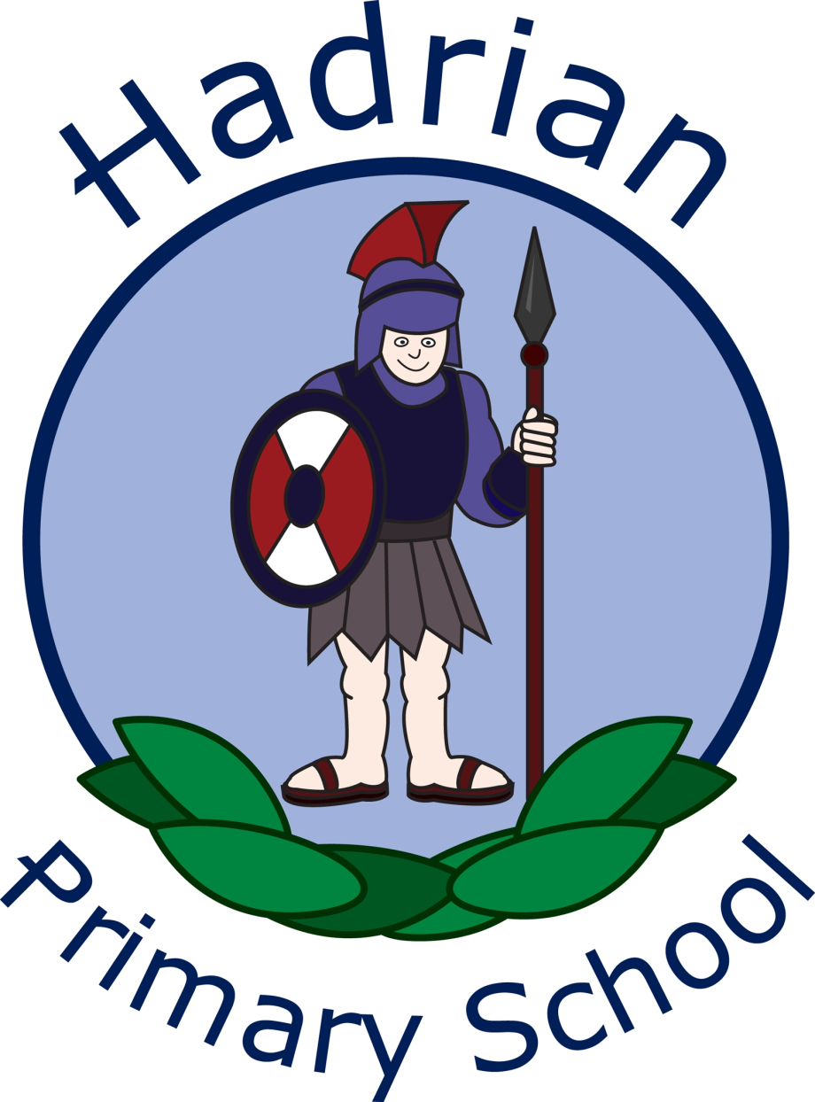

Hadrian Primary School
English Policy
June 2025

Staff responsible:

Mr S Brown-Head Teacher

Miss J Pattison-Deputy Head Teacher

Mrs S Stout- English Lead

Intent
At Hadrian Primary, we prepare pupils for their futures and recognise the paramount importance of all aspects of English. Reading, oracy, writing, grammar and spelling, are skills that are fundamental to unlocking all areas of the curriculum and, just as important, the world around them. We are proud of our English curriculum, which promotes high standards of language and literacy by means of equipping children with a strong command of the spoken and written word. A love of literature is cultivated in school through a rich and varied curriculum that encourages exploration and engagement with diverse texts. By incorporating classic and contemporary works, staff ignite the imagination of pupils and inspire their critical thinking. A supportive environment for discussion and interpretation, enables pupils to articulate their thoughts and emotions, enhancing their appreciation for the written word. These experiences encompassed with widespread reading across the curriculum, daily DEAR sessions and reading for pleasure, nurture and create a lifelong passion for literature.

The teaching of English at Hadrian creates endless opportunities to develop pupils’ skills in reading, writing, speaking, and listening. Our school vision, Being unique: believing, achieving, succeeding together, guides and influences learning by ensuring that all of our children are provided with rich experiences and learning opportunities to achieve their full potential in all areas of English.
Effective and impactful teaching of English is crucial for enabling pupils to succeed across all areas of the curriculum. Proficiency in English enhances pupils’ reading and writing skills, alongside fostering critical thinking and effective communication abilities. These competencies are essential as they underpin learning in subjects across the curriculum, where the comprehension of complex texts and the articulation of ideas are paramount. Furthermore, a strong foundation in English equips pupils with the tools necessary to engage in collaborative discussions, facilitate problem-solving, and express their understanding, thereby promoting overall academic achievement and confidence.
We have a high percentage of children with English as an additional language in our school, which can mean that some of our children’s early language acquisition is impacted. We aim to provide a language-rich environment with a strong focus on oracy, to enable success and progression for all of our children.

Reading
At Hadrian, we believe the integration of reading within the school curriculum significantly enhances pupils' cognitive and social development. Engaging with diverse texts fosters critical thinking, broadens vocabulary, and cultivates a lifelong love of literature. Reading encourages empathy and cultural awareness, enabling students to connect with varied perspectives. Our school's commitment to promoting reading is evident within our curriculum, our learning environments, daily DEAR sessions and our well-resourced reading corners and library, all of which aim to inspire reluctant and enthusiastic readers alike. Ultimately, prioritising reading contributes to improved academic performance across subjects and equips children with essential skills for their future endeavours in an increasingly complex world.

Writing
At Hadrian, we understand the importance of writing within the school curriculum and the profound impact it has on the cognitive and linguistic development of our pupils. Through structured writing exercises, children enhance their critical thinking and communication skills, alongside developing creativity and self-expression. We want children to write clearly, accurately and coherently, adapting their language and style for a range of contexts, purposes and audiences. Regular engagement with varied writing structures—such as narratives, non-chronological reports, and poetry—cultivates a greater understanding of language mechanics, style and vocabulary. We want children to write clearly, accurately and coherently and be able to adapt their language and style to suit the relevant written outcome. Children are exposed to a wide and rich vocabulary that enhances their writing, alongside enabling them to express ideas effectively. Developing spelling proficiency is essential for all children, as it underpins effective written communication and boosts confidence in writing abilities. We aim to ensure children strive for continuous improvement in our inclusive culture of learning, as well as equip pupils with the necessary tools for academic success and prepare them for future professional environments.

Speaking and Listening
Speaking and Listening encompasses the curriculum in its entirety and is the catalyst for further language development and overall academic success. Speaking and listening skills enhance communication, critical thinking and emotional intelligence. Engaging in discussions, enables pupils to develop confidence and articulacy, allowing them to express ideas and opinions effectively. The language of pupils reflects the heritage and local culture, which is valued and built upon, whilst ensuring pupils become competent in the use of Standard English. Strong listening skills promote comprehension and empathy, which are essential components of a supportive learning environment. By prioritising these competencies within the curriculum, Hadrian equips learners to navigate social interactions, thus preparing them for future challenges in academic pursuits and personal endeavours.

Implementation
The implementation of English in Early Years is guided by the EYFS Statutory Educational Programme facilitated through Development Matters. The National Curriculum establishes a coherent framework for teaching the subject from Key Stage 1.
At Hadrian, English serves as a fundamental area of academic study, playing a crucial role in developing critical communication skills that are essential for our pupils’ success throughout their education and beyond. We offer a balanced programme that encompasses reading, writing, and speaking and listening skills, alongside emphasising exposure to a wide range of texts, which promotes and encourages creativity through imaginative writing. Teachers are expected to employ varied pedagogical approaches, catering to the needs of all learners, ensuring that each pupil is able to engage with, and appreciate, the richness of the English language. The impactful and effective teaching of English plays a pivotal role in fostering literacy and enhancing overall educational outcomes for children.
In English lessons, the needs of all children are effectively met through support tailored to individual learning needs, enabling students to recall and build on prior knowledge. Teachers employ the most effective strategies for their learners, such as scaffolded tasks, varied reading materials, and targeted feedback. This ensures that each child engages with the curriculum at an appropriate level, and continues to make progress. Providing an inclusive learning environment, where all students feel safe to explore ideas and express themselves, facilitates a deeper understanding of language and literature, ultimately enhancing children’s confidence and capabilities.

Reading
To form the foundations for lifelong readers at Hadrian, early literacy skills are promoted and developed from Nursery. This is implemented through play-based activities, storytelling, phonemic awareness, and recognising rhythm, rhyme and alliteration. The National Curriculum outlines a structured approach to literacy, ensuring continuity in reading development as children progress through their educational journey. In Reception and Key Stage 1, phonic lessons take precedence; the Sounds-Write linguistic phonics programme is employed to provide a systematic method for recognising grapheme-phoneme correspondence, decoding words, blending sounds, and building vocabulary. This programme aligns with the phonics screening check introduced in Year 1, and lays a strong foundation for fluency in reading. Within Reception and Year 1, the teaching of phonics is enhanced by activities such as Polly Phonics, delivered by South Shields FC. Planned intervention strategies enhance and progress the reading abilities of children identified as working below the expected standard, by providing tailored support that addresses individual learning needs. Children who require further support in phonics in KS2, continue with dedicated phonics sessions and intervention support. Through targeted instruction, regular monitoring, and tailored resources, these interventions promote engagement and boost confidence, ultimately improving literacy outcomes within an inclusive learning environment.
Reading fluency is effectively promoted across the school through a structured approach that aligns with the Sounds-Write phonics programme. Ensuring that books are carefully selected to match phonics progression, enables children to develop their decoding skills in a systematic manner. Regular reading sessions, in-class and at home, allows students to develop fluency and prosody, alongside deepening their comprehension skills in a supportive environment.
Within Year 2 and moving into KS2, we have a variety of different reading schemes (such as Dandelion Readers, Sounds-Write and Project X) and a wide range of appropriate, quality texts that cover all genres. Our books have been banded to facilitate the development and progression of reading skills amongst our learners. By categorising texts into specific bands based on complexity, we can ensure that pupils engage with a diverse range of materials that are appropriate to their current reading abilities. This method fosters fluency, enabling learners to read with greater speed and accuracy. Exposure to a varied vocabulary enriches the linguistic repertoire of our pupils, whilst the incorporation of prosody—namely, the rhythm and intonation of speech—enhances comprehension and overall engagement with the text, thereby supporting holistic reading development.
We ensure and encourage sufficient practise in reading and re-reading books that match the grapheme/phoneme correspondence already known, in school and at home. Re-reading books offers numerous benefits that enhance comprehension and facilitate a deeper connection with the text. Engaging with familiar material allows readers to develop automaticity in recognising vocabulary and structure, which consequently increases reading fluency. As readers revisit a narrative, they often uncover nuances and themes that may have been overlooked during the initial reading. This iterative process solidifies understanding, alongside encouraging critical thinking and analytical skills. The emotional resonance of reconnecting with characters and plotlines can deepen one’s appreciation for literature, making re-reading a valuable practice in the pursuit of academic excellence.
At Hadrian, we use Boom Reader as a tool to record reading within school and at home. This platform allows teachers to monitor and assess pupils' reading habits by providing a digital space where learners can log their reading activities. By encouraging regular reading and reflection, Boom Reader assists in tracking individual progress and identifying areas where additional support may be necessary. The platform offers a range of engaging features, such as the ability to set reading goals, provide instant feedback, and celebrate achievements, thereby motivating pupils to develop their literacy skills. The integration of Boom Reader into the curriculum not only enhances the enjoyment of reading but also supports the development of critical comprehension and analytical skills.

Reading development within our school is implemented through a range of strategies designed to cater to the individual learning needs of our pupils. Shared reading sessions promote a love for literature, encouraging discussion and collaborative engagement with texts. Guided reading groups allow for targeted instruction, enabling teachers to focus on specific skills and comprehension strategies. Additionally, we prioritise 1:1 reading sessions, which provide personalised support, ensuring that each child receives the support they need for consistent progression.

At Hadrian, we create a culture that promotes a love of reading and a passion for literature, beginning in nursery and continuing through to Year 6. Our school library and classroom reading areas boast a wide and varied range of classic and contemporary texts, alongside opportunities for independent exploration. This extensive range ensures that all pupils, regardless of their reading preferences, can find books that captivate and inspire them. We actively cultivate a rich reading ethos by embedding literature into our daily routines. Daily DEAR sessions (Drop Everything And Read), expose children to different genres and authors and instil a love for sharing books. Special events, such as World Book Day and National Poetry Day, further galvanise our commitment to reading; these occasions allow pupils to engage creatively with texts, share their favourite stories, and participate in themed activities that celebrate literature. Additionally, our strong links with the local library (The Word), enables children to access a broader selection of quality texts, encouraging them to pursue reading beyond the classroom. By supporting our pupils with an immersive reading experience and providing a wealth of literary resources, we aspire to create lifelong readers who appreciate the power of words and storytelling.
We believe that instilling a love for reading extends beyond the classroom; therefore, we implement various strategies to encourage reading at home. In KS2, children can access Reading Plus, an interactive programme designed to enhance reading skills whilst providing personalised content appropriate for each child’s level. In KS1, we utilise Bug Club, a dynamic digital platform that offers a wide array of engaging books, which cater to diverse interests and reading abilities. To further stimulate enthusiasm for reading, we organise themed reading challenges throughout the academic year. These challenges motivate students to explore new genres and broaden their literary horizons, often culminating in celebratory events that recognise their achievements. Through these initiatives, we aim to create a home environment conducive to reading, thereby instilling a lifelong passion for literature in our pupils.

Writing
At Hadrian, we are dedicated to nurturing a positive writing culture that ensures progress, whilst simultaneously inspiring creativity and self-expression amongst pupils. Our engaging and structured curriculum is designed to build on prior learning, facilitating the acquisition of transferable skills from one topic to the next. Pupils are given opportunities to apply their knowledge in a range of contexts, enhancing their understanding and development of the written word.
We display children's written work in various communal areas, such as hallways and classrooms, creating a sense of pride and ownership in their achievements. This practice enhances the visibility of their efforts, as well as encouraging peer admiration. Allowing children the opportunity to share their writing with others in class, provides opportunities for positive and constructive peer feedback, enabling children to edit and improve their work within the writing process. At the end of some teaching sequences, children have the opportunity to perform their writing for children in their class to access on Seesaw. We also share learning within our school community through social media platforms, modelling to children that our learning goes beyond the classroom.
‘Free Write Friday’ serves as a vital catalyst in creating and sustaining passion and pace within the writing process. By incorporating a visual prompt (such as an evocative image) or a written prompt, pupils are invited to ignite their imagination and delve into creative expression without fear of critique. This structured spontaneity cultivates an enjoyment for writing, enabling students to embrace their unique voices whilst maintaining a steady flow of creativity.

Within the English curriculum, the teaching of composition and transcription is a multifaceted approach that combines the development of writing skills with a focus on spelling, punctuation, and grammar (SPaG) content. The integration of resources such as Spelling Shed, enables pupils to engage with spelling in an interactive manner, facilitating improved retention and application of spelling rules within their writing. The use of Letter-join supports handwriting proficiency, allowing students to form letters correctly and develop a cursive style that enhances the readability of their written work.
Incorporating drama within writing serves to enrich the composition process, as it encourages pupils to explore narratives and character development through performance. This experiential learning fosters creativity and aids the generation of ideas for written work, as well as creating an awareness of audience, purpose, context and widening vocabulary. Children are prompted to draw upon personal experiences to engage with various genres, ultimately allowing them to express their thoughts and feelings more effectively. Through constant practise in both composition and transcription, learners are well-prepared to navigate the complexities of written communication in their academic pursuits and beyond.

The implementation of a literature spine within our curriculum significantly engages children in their reading and writing endeavours. This carefully curated selection features quality texts specifically chosen for each year group, ensuring that children are exposed to literature that is age-appropriate and intellectually stimulating. Updated annually, the literature spine incorporates new book releases, thereby keeping the selection fresh and relevant to contemporary issues and themes. As pupils engage with these texts, they develop a deeper understanding of narrative techniques, including plot structure, character development, and varied vocabulary, which in turn enriches their own writing capabilities. The literature spine not only nurtures a love for reading, but also cultivates critical thinking skills, allowing children to draw connections between genres and themes within their development of writing.

The teaching of writing at Hadrian is meticulously structured to encompass a broad range of genres, thus ensuring that pupils are equipped with the skills necessary for effective communication. Throughout the curriculum, opportunities for writing are seamlessly integrated, allowing for a holistic educational approach that enriches pupils' creativity and expression. The genre coverage is strategically mapped to ensure cohesive progression across the whole school, fostering continuity in learning as pupils transition from Key Stage 1 to Key Stage 2.

Daily literacy lessons are organised according to a common teaching sequence, which is consistently applied across both key stages. This sequence encompasses the benchmarking of prior knowledge, facilitating the comparison of reading exemplars and texts, as well as exploring vocabulary. Furthermore, it incorporates the explicit teaching of spelling and grammar objectives in context, directly related to the topics the children are engaged with. The teaching sequence promotes a gradual release of responsibility through shared and guided writing, empowering children to produce their own independent pieces.
In addition to routine writing activities, our fortnightly independent extended writing lessons allow students to demonstrate their learning and understanding in a focused manner, revisiting the genre explored two weeks prior. These sessions also present opportunities for cross-curricular writing, aligning with whole school celebrations such as Black History Month, International Women’s Day, Children in Need, and World Book Day, thereby enabling a sense of relevance and community engagement within their writing endeavours.

Feedback in English functions as an essential tool for learning, enabling pupils to understand their strengths and areas for improvement. Daily feedback, whether delivered on a one-to-one basis or within a whole-class setting, helps to address misconceptions promptly and effectively. This ongoing dialogue creates a supportive atmosphere where students feel encouraged to check and refine their work. Allowing time for students to edit and enhance their writing based upon the feedback received, empowers them to take ownership of their learning journey, ultimately leading to improved confidence and mastery of the subject.
Each child's progress is meticulously tracked through our online tracker system, allowing us to monitor individual improvements over time. We conduct termly key stage moderation sessions, where teachers collaboratively evaluate writing standards to ensure consistency and rigour across year groups. Whole school writing moderation further enhances this process, creating a culture of shared best practices and collective accountability amongst staff.
To enrich the feedback process, we provide regular opportunities for pupils to engage in self and peer assessment of their writing. This empowers children to take ownership of their learning and cultivates critical thinking and reflection of their writing techniques. Alongside verbal and written feedback from teachers, children gain clear insights into their next steps in the writing journey, guiding them towards the completion of high-quality written pieces. This comprehensive approach ensures that assessment is not merely an endpoint but serves as an essential tool for informing teachers’ planning and adapting instructional strategies moving forward, thereby supporting each child in achieving their full potential.
At Hadrian, we have a KS2 moderator for the local authority who oversees whole school moderation alongside the English Lead.

How English is taught in Early Years
The implementation of English in Early Years is guided by the EYFS Statutory Educational Programme facilitated through Development Matters. Communication and Language and Literacy areas from the Framework are focussed on with the utmost importance, as they underpin all other aspects of learning. Communication, language and literacy are taught discretely and woven through daily routines.

Communication & Language
In the Early Years, English is taught with a strong emphasis on fostering children's language development through a variety of engaging and stimulating activities. To support all children’s language development, as many opportunities as possible are offered throughout the day, ensuring a rich linguistic experience. For those children for whom English is an additional language, tailored support is provided to facilitate their integration and enhance their confidence in using and applying the language. The Early Years environments are designed to promote a 'language-rich' atmosphere, critical for developing vocabulary and communication skills. This is achieved through the use of natural, open-ended resources that encourage spontaneous talk, questioning, and imaginative play.
An array of diverse and traditional high-quality texts is readily available, both within the classroom and in designated reading areas, creating a seamless connection between literature and activities. Practitioners carefully plan challenges and enhancements within the classroom environments to encourage dialogue and support verbal expression. Daily circle time sessions further promote talk in large and small groups, as well as one-to-one interactions within continuous provision, thus instilling a culture of communication.
Children are immersed in stories, songs, rhymes, and poems during daily ‘Drop Everything And Read’ (DEAR) time, which not only builds listening and attention skills but also reinforces phonological awareness and vocabulary acquisition. Teachers and practitioners engage in quality interactions to model correct language use and to extend children’s vocabulary. To ensure that all children meet age-related milestones, they are screened using the Every Child a Talker (ECAT) tool, which helps identify those in need of speech and language support. This screening informs high-quality early intervention programmes, such as Colourful Semantics and targeted ‘box times’, ensuring that every child receives the targeted assistance they require to thrive.

Literacy
In the Early Years, literacy is approached with an emphasis on encouraging a genuine enjoyment of books and stories, which forms the cornerstone of our educational philosophy. A variety of texts, including fiction, non-fiction, and poetry, are strategically utilised to plan topics that are not only linked to key literacy skills but also aligned with the interests of the children. This ensures that the engagement with literature is relevant and stimulating. Enjoyment of books is prioritised throughout the day, transcending the confines of ‘literacy’, as books are integrated into every area of learning. Adults employ dialogic book talk to enhance children's understanding and comprehension, encouraging rich discussions that deepen their connection to the text.

To bring stories to life, we harness creative methods such as role play and small world activities, allowing children to immerse themselves in narratives. It is not uncommon for children to encounter elements from beloved stories, such as discovering the witch’s broomstick from "Room on the Broom" in the Early Years garden or spotting the suspicious footprints left by the Gingerbread Man. This excitement around stories cultivates a desire for independent reading. The implementation of the Sounds-Write programme, complementing fully decodable texts, equips children with the skills to blend and segment phonemes, promoting confident, independent reading.

Writing in the Early Years begins with mark making, providing children with various opportunities to develop fine and gross motor skills essential for writing readiness. Daily activities such as ‘Dough Disco’ and ‘Squiggle While You Wiggle’ engage children in physical play that supports their developmental needs. As children progress to Reception, writing is explicitly taught during Literacy lessons, followed by ample opportunities to practise these skills in continuous provision. We actively encourage independent writing, emphasising the importance of writing for a purpose, which reinforces its relevance in everyday life.

How English is taught at Hadrian

Phonics
Phonics is taught in a highly structured linguistic phonic approach; Sounds-Write. Reception, Key Stage 1 and Year 3 access daily lessons. For children identified needing additional support in KS2, children are taught in appropriate intervention groups. At Hadrian, it is our aim to provide children with the skills necessary to be able to read confidently and fluently and to be able to access information across the full curriculum.
Children are given daily opportunities to develop their reading skills. In Nursery, pupils begin to develop their listening skills and to discriminate between sounds, recognising rhythm, rhyme and alliteration. They develop oral blending and segmenting of sounds in words. This is enhanced through Launch Pad for Literacy and the BLAST programme, which support language and communication development. In Reception and KS1, children learn to read using the Sounds-Write linguistic phonics approach.
The following conceptual knowledge is taught:

• Letters are symbols (spellings) that represent sounds.
• A sound may be represented or spelled by 1,2,3 or 4 letters e.g. dog, street, night, dough.
• The same sound may be spelled in more than one way (one sound- different spellings) e.g. rain, break, gate, stay.
• Many spellings can represent more than one sound (one spelling- different sounds) e.g. head, seat, break.
They develop the skills of blending (combining sounds together to build words), segmenting (breaking up a word into individual sounds) and manipulating sounds to read and spell words correctly. This is carried out daily in Reception and Year 1 and is enhanced by Polly Phonics facilitated by South Shields FC. In Years 2 and 3, the Sounds-Write approach is continued and the rules and concepts of spelling are introduced. Key Stage 2 pupils who require further support in phonics, continue with dedicated phonics sessions.

Phonics Assessment
Children’s progress is continually reviewed. We endeavour to ensure that children ‘keep up’ not ‘catch up’. Where children aren’t meeting age-related expectations, they will become part of an intervention group that will focus on the particular skill or sounds that they are finding difficult. Children are formally assessed at the end of each term.
Year 1 children will complete a National Phonic Screening Check in June. This assessment tests children’s ability to decode to an age-related expected standard at the age of 6 years old. The Phonic Screening Check requires children to read 40 words in a one-to-one situation with a familiar teacher. These are a mixture of words and pseudo words. If children do not reach the pass mark, they have an opportunity to retake the check in Year 2. As children enter KS2, provision is made for those children still requiring phonic support.
Parents of children in Year 1 and parents of children that did not reach the pass mark in Year 2, will be invited to a phonics workshop. This gives parents information about how they can best support their children at home.

Reading for Pleasure
Reading is one of life’s great pleasures and perhaps its greatest treasure. At Hadrian Primary, we firmly believe that inspiring a lifelong love of reading and books is the most precious gift we can bestow upon our children. Thus, reading and books occupy a central role within our curriculum, as we are committed to ensuring that all of our pupils are equipped to read for pleasure and maintain high standards in their literacy skills. Our ultimate aim is to stimulate their imaginations, unlocking countless realms of awe, wonder, and joy.
To cultivate a culture of reading for pleasure, we embed this ethos throughout the curriculum. Special occasions such as World Book Day, Roald Dahl Day and National Poetry Day, are celebrated with enthusiasm, serving to elevate the profile of literature within our school community. We host a Book Fair every academic year, which offers every child the opportunity to explore a diverse array of new books, encouraging them to purchase and take home reading material that resonates with their interests.
We establish strong partnerships, notably with The Word in South Shields, and actively encourage our students to engage in the summer reading challenge. This initiative, alongside workshops and educational trips conducted throughout the academic year, enhances our pupils’ appreciation for literature. Regular reading assemblies led by Senior Management introduce various literary works, enriching children’s exposure to different authors and genres.
Each day, the school adopts a dedicated period known as ‘Drop Everything And Read’ (DEAR Time), allowing students to experience fifteen precious minutes of immersive reading. Book selections are informed by children’s personal preferences, recommendations, and opportunities to introduce new authors and texts. This practice cultivates independent reading habits and allows for exploration of varied genres. Sharing books from home during class discussions or DEAR time, adds a personal touch, enabling children to share their favourite titles and authors, thus enriching the learning experience. Incorporating a range of texts, including graphic novels and informational texts, helps stimulate curiosity and encourages critical thinking.
Beyond the classroom, our main school library is readily accessible, offering children the chance to explore a plethora of genres, including ambitious texts that broaden their literary horizons. Our library reinforces the importance of reading through initiatives such as an author and theme of the month, with children encouraged to suggest and vote for new acquisitions. Furthermore, the Reading Cloud connected to our library provides access to hundreds of e-books, allowing students to engage with literature at home and school. Pupils are also invited to write blogs and book reviews, which are reviewed by the library coordinator and subsequently shared on the school system, creating a vibrant reading community. Collectively, these strategies aim to instil a genuine passion for literature.

Assessment of Reading
The assessment of reading is a multifaceted process that incorporates day-to-day, on-going assessments and formal testing measures to ensure each child's development is effectively monitored. Day-to-day assessments serve as a crucial method of evaluation, providing instant feedback to teachers and enabling them to address the individual needs of pupils during each lesson. Until children reach the stage of being ‘free readers’, their reading progress is meticulously tracked using a colour bands tracker, and those who raise concerns are closely monitored. For children reading below age-related expectations, targeted intervention groups are established with the aim of closing any reading gaps. The effectiveness of these interventions is evaluated through regular phonics screening checks conducted in Year 1. Further assessments involve Salford Reading Tests in Year 2 and Year 3, along with Reading Plus progress assessments from Year 3 to Year 6.
In addition to these formative assessments, termly summative reading tests are administered during assessment weeks to gauge how well children are meeting age-related expectations. It is crucial to note that those children who have not yet developed decoding skills, will undertake reading assessments in the form of supported guided reading sessions, ensuring they receive the appropriate level of support whilst maintaining a focus on their development as readers. This comprehensive approach ensures that teachers are equipped with the necessary information to facilitate targeted instruction and promote literacy success for all students.

Writing and Handwriting
At the start of Early Years, early writing is primarily characterised by mark making, which serves as a foundational stage for children’s literacy development. During this critical period, children are provided with a wealth of opportunities to cultivate their fine and gross motor skills, essential for the successful transition into writing. Activities such as the daily “Dough Disco” and “Squiggle While You Wiggle”, play a significant role in enhancing these skills through engaging and enjoyable practices. Furthermore, children are encouraged to explore mark making using a variety of materials and techniques, establishing a genuine interest in writing and laying the groundwork for later stages of literacy development.
As children progress into Reception, formal writing instruction is integrated within Literacy lessons. Here, writing becomes more structured, yet children continue to have plentiful opportunities to practise the skills they have learned in their continuous provision. Such an approach not only reinforces their literacy learning but also encourages independent writing initiatives that reflect their interests. Emphasising the significance of writing for a purpose helps children recognise its vital role in everyday life, thereby nurturing a deeper appreciation for the act of writing itself.
In parallel with their developing letter sounds, children receive guidance on correct letter formation, which is effectively woven into both their independent and supported writing exercises. This dual focus on transcription—encompassing both spelling and handwriting—ensures that children are not only able to express their ideas effectively but also do so with the appropriate technical skill. The programmes of study for writing at Key Stages 1 and 2 delineate two essential dimensions: transcription and composition. While transcription addresses the technical aspects of writing, including spelling and the formation of letters, composition is focused on the articulation of ideas and their effective structure in both speech and written form.
This holistic approach to writing education ensures that children are equipped with the necessary skills to navigate their literacy journey successfully. By integrating engaging practices within the Early Years and establishing an environment that promotes technical proficiency and creative expression, we lay a strong foundation that supports children's writing development throughout their educational experience. The careful implementation of writing and handwriting instruction not only adheres to the educational standards, but also empowers children to become confident, capable, and literate individuals in a rapidly evolving world.

Speaking and Listening
Speaking and listening skills are intrinsically woven into the fabric of the curriculum, serving as a foundation for holistic development in communication. At Hadrian, we firmly uphold the principle that effective speaking skills directly impact writing proficiency; if a child is unable to articulate a sentence, it stands to reason that they will struggle to transcribe that thought coherently on paper. This philosophy underpins our pedagogical approach, leading us to integrate oracy activities at every stage of the educational journey.
Beginning with an emphasis on 'Talk for Writing', we incorporate dynamic, interactive methods that engage children actively in the process of composition. This approach is embedded throughout every phase of the writing sequence, enabling pupils to internalise narrative structures and vocabulary, whilst simultaneously learning to express their ideas verbally. We create an environment where children can engage in discussions, collaborate with peers, and articulate their thoughts confidently, thus refining their communication skills.
We place significant importance on the physical aspects of writing. Pupils are taught the fundamentals of good posture, which, along with proper pencil grip, lays the groundwork for fluent handwriting. The curriculum guides them through writing from left to right across the page, ensuring that they form appropriately sized letters, with systematic finger spacing. This structured progression culminates at the end of Year 2, when pupils transition into Year 3, successfully joining letters to form a cursive script. We constantly encourage children to take immense pride in their written work, recognising the link between their expressive abilities and their written output. This comprehensive approach ensures that speaking and listening remain at the heart of our curriculum, empowering students to become proficient communicators.
Our Writing Teaching Sequence
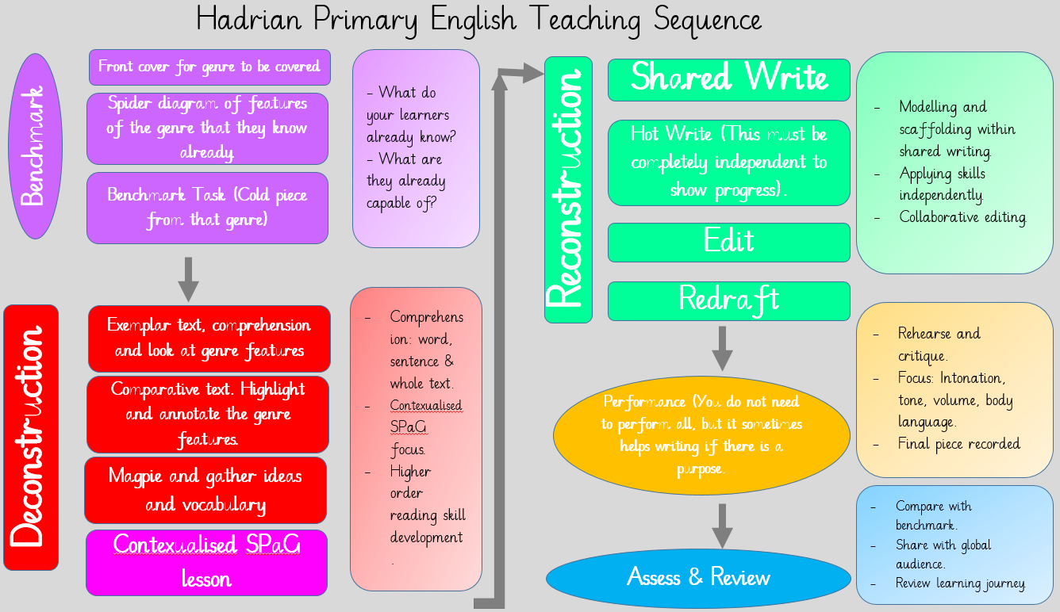

Each part of the teaching sequence is explained below.
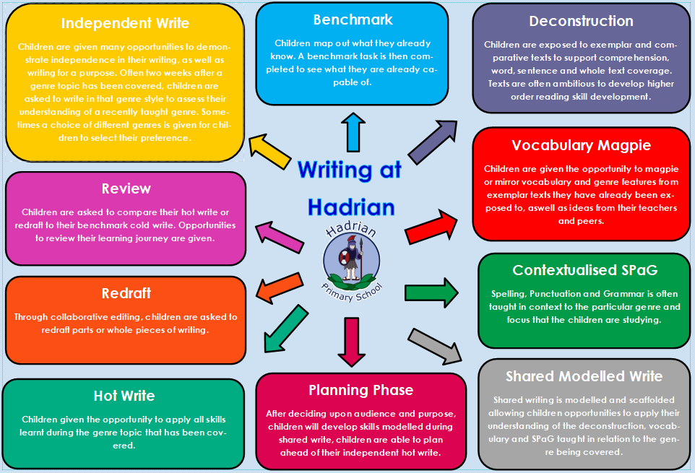
This sequence will support the teaching of different genres of writing, however, not all teaching of English will be suitable to be taught through this sequence.
Spelling
Spelling skills are intricately woven into the curriculum from Reception through to Key Stage 2, ensuring that children develop a robust foundation in literacy. From Reception pupils are instructed in spelling through our Sounds-Write linguistic phonics approach, which enables them to understand and apply different ways of spelling sounds, or graphemes. This method focuses on the decoding of words, alongside encouraging children to apply their phonetic knowledge in their writing, including words, captions, and sentences. It is vital that alongside decodable words, pupils are taught to read and spell Common Exception words—those which cannot simply be sounded out—to enhance their overall literacy skills.
As children progress into Key Stage 2, the curriculum shifts towards a more exploratory approach to language. Pupils will investigate the origins and connections between words (etymology and morphology), which helps to enable a deeper understanding of vocabulary. To support this, specific wordlists for Years 3 and 4, as well as Years 5 and 6, are provided. These lists comprise a blend of frequently used words alongside those commonly misspelled, reinforcing spelling proficiency. We endeavour to embed spelling opportunities throughout all subjects, cultivating a holistic learning environment.
Spelling lessons are thoughtfully integrated into the timetable to enhance literacy skills and promote a robust understanding of language. We have adopted a systematic approach that utilises engaging resources, including the online platform Spelling Shed, which provides interactive and enjoyable spelling activities. Each week, pupils are allocated dedicated sessions, allowing them to focus on specific spelling rules and patterns. These lessons are designed to improve spelling proficiency, as well as developing phonemic awareness and vocabulary acquisition.
Teachers carefully select spelling lists that align with the curriculum and cater to varying ability levels, ensuring that all learners are supported in their progress. In addition to direct instruction, children are encouraged to participate in collaborative learning activities, where they can engage with peers and practise new words through games and challenges available on Spelling Shed. Regular assessments are conducted to monitor progress and identify areas that may require further attention.

Vocabulary, Grammar and Punctuation
The development of vocabulary, punctuation, and grammar is paramount to enabling effective communication skills in children. Through talk and reading, children's vocabulary is enriched as they engage with a variety of texts. This vocabulary is often drawn from the books they read and subsequently displayed, allowing for reinforcement and learning over time. Such an immersive approach enhances lexical knowledge, alongside encouraging children to explore language in context.
Grammar and punctuation are integral components of the English teaching sequence. It is crucial that these elements are taught in a contextualised manner, linking directly to the specific genre of English being studied. Children are introduced to various grammatical concepts and are then actively encouraged to apply and recognise these elements within both written and spoken contexts. The curriculum prescribes specific punctuation and grammatical terminology for each year group, ensuring alignment with National Curriculum expectations. Through this structured approach, pupils gain a comprehensive understanding of language mechanics, empowering them to articulate their thoughts with precision and clarity. Ultimately, the synergy of vocabulary, grammar, and punctuation significantly contributes to the holistic development of our children’s literacy skills.

Assessment and Recording
Assessment and recording in English is a crucial component of the educational process, ensuring that teachers effectively measure and support the progress of all pupils. Teachers make assessments integral to every lesson, continuously evaluating pupils' understanding and engagement with the planned learning objectives. Feedback is provided in alignment with these objectives, enabling children to recognise their strengths and areas for improvement. In this context, spelling and grammar mistakes are not only identified but also corrected, promoting a culture of learning where students feel supported in their development. This formative assessment approach provides teachers with the necessary insights to adjust daily plans, catering to the varying needs of their pupils. Our online tracking system plays a significant role in monitoring pupil progress against age-related expectations, with assessments carried out every half term. Additionally, children complete termly grammar, punctuation, and spelling tests to further aid in their learning journey. At the culmination of Year 2 and Year 6, pupils undertake national standard assessment tests (SATs), which evaluate their overall attainment. Writing is levelled in accordance with the teacher assessment framework for Key Stage 1 and Key Stage 2, ensuring a consistent and comprehensive assessment process across the key stages.

Resources
There is a range of resources to support the teaching of English across the school, ensuring that teachers and pupils have the tools necessary for effective learning. Classroom displays are thoughtfully curated to reinforce key aspects of the English curriculum, offering visual support for various topics and concepts. In every classroom, teachers can access a selection of poetry, fiction, and non-fiction texts, alongside the designated Literature Spine for each year group. This selection enriches the literary experience whilst also broadening pupils' exposure to different genres and writing styles. Centrally stored resources, including Big Books, Guided Reading Books, and teacher’s handbooks, enhance instructional strategies and facilitate targeted learning.
Pupils benefit from access to the Internet and a variety of educational programmes available through computers, iPads and laptops. This technology allows for interactive and engaging lessons, catering to a range of learning preferences. The school library complements these resources by housing a wide range of books that cater to children’s interests and support individual research.
Platforms such as Plazoom and Grammarsaurus provide access to exemplar texts and Tier 2 vocabulary resources, crucial for enriching the language and comprehension skills of our pupils. Collectively, these resources create a dynamic and supportive environment for the teaching and learning of English across the school.

Monitoring and Review
At Hadrian, we prioritise the continuous monitoring and reviewing of English standards to ensure that both teaching and learning remain of the highest quality. The responsibility for the oversight of children's work as well as the efficacy of English instruction lies primarily with the English subject leader in conjunction with the Deputy Head, who is a Key Stage 2 moderator for the Local Authority. The English Lead and the Deputy Head review English books on a termly basis, ensuring consistency and adherence to educational standards.
The role of the subject leader extends beyond oversight; it encompasses supporting colleagues with the teaching of English, staying informed about current developments within the subject, and providing strategic direction. In collaboration with the SLT, the subject leader identifies key areas for improvement, which are systematically recorded within the school’s development plan. To facilitate thorough review and assessment, the English Lead is allocated regular management time to monitor and scrutinise samples of pupils’ work, engage in pupil interviews and collect pupil voice, and observe English lessons across the school.
Furthermore, the enhancement of our English provision is aided by the involvement of the designated governor responsible for literacy, who meets annually with the subject leader to evaluate progress against set objectives. This robust monitoring and review framework not only reinforces our commitment to high standards in English, but also promotes professional development and collaborative practices amongst staff, ultimately maintaining a rich learning environment for our pupils. Through these mechanisms, we ensure that the teaching of English at Hadrian continues to evolve and meet the needs of all our learners.

Impact
By the end of their journey at Hadrian Primary School, we endeavour to ensure that children leave with highly developed communication skills, preparing them for secondary education and beyond. Success is not only achieved through children’s attainment, but through their engagement with, and enthusiasm for, the many English opportunities that have been provided throughout their time with us.
The English curriculum we implement has a profound impact on our students, fostering an inclusive culture of learning that caters to the varying needs of all learners, irrespective of their initial starting points in English. Particularly, for those with early developing English speaking skills, our curriculum provides tailored challenges that engage them in critical thinking and problem solving. Through a structured progression, we equip children with essential skills and knowledge to communicate effectively and confidently. This not only enables them to contribute meaningfully to their local communities but also empowers them to engage on a global scale. By instilling a sense of responsibility and encouraging sustainable practices, we prepare our pupils to understand their role in shaping a viable future for themselves and for society as a whole. Thus, our English curriculum plays a crucial role in developing articulate, conscientious individuals ready to navigate and contribute positively to an ever-evolving world.

Reading
When our children leave our school, we expect them to be avid readers. Children can read fluently and widely, with a thirst for reading a range of genres and text types; including poetry. Children appreciate the joy and wonder of reading and are able to express preferences and opinions about the texts that they read.
We designed our English curriculum to encourage and facilitate children to connect with a deep love for reading, culminating in our expectation that, when our children leave, they are not only proficient in reading but also avid readers. Our curriculum emphasises fluency and encourages children to engage with an array of genres and text types, including poetry, thereby broadening their literary horizons. This exposure is vital in cultivating a genuine thirst for knowledge and an appreciation for the joy and wonder that literature can provide. As a result, our pupils develop the ability to articulate their preferences and opinions about the texts they encounter, ensuring they are not mere consumers of literature but critical thinkers who can engage with texts on a profound level. Ultimately, the impact of our curriculum is evident in the confident readers our pupils become, equipped with the skills necessary for lifelong learning.

Writing
The English curriculum at Hadrian serves as a fundamental pillar in enhancing our children's writing outcomes, equipping them with vital skills for effective communication and self-expression through the written word. Through our targeted approach, pupils learn to write across a range of forms, enabling them to adapt their style and content successfully according to purpose and audience. This versatility not only fosters creativity, but also ensures that our pupils are well-prepared for the transition to secondary school, where they will encounter more complex writing tasks. The outcome of work showcased in English and foundation books, evidences the high quality of pupil achievements and the positive impact of our cross-curricular writing opportunities. By integrating writing across subjects, we cultivate an enriching learning environment that promotes critical thinking and comprehensive literacy, ultimately preparing our young learners for future academic challenges.

To be reviewed by: June 2027

