Google Classroom info
Hi all, this is just a little reminder about Google Classroom and logging in. We have been going over logging in during our computing lessons and some children had to have their passwords reset. So, their details are attached to your parent pack.

hadrianprimary.org.uk
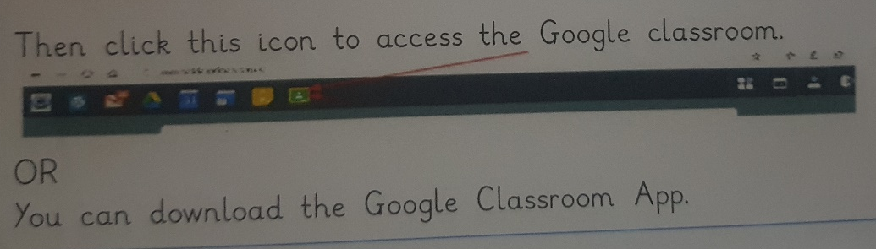

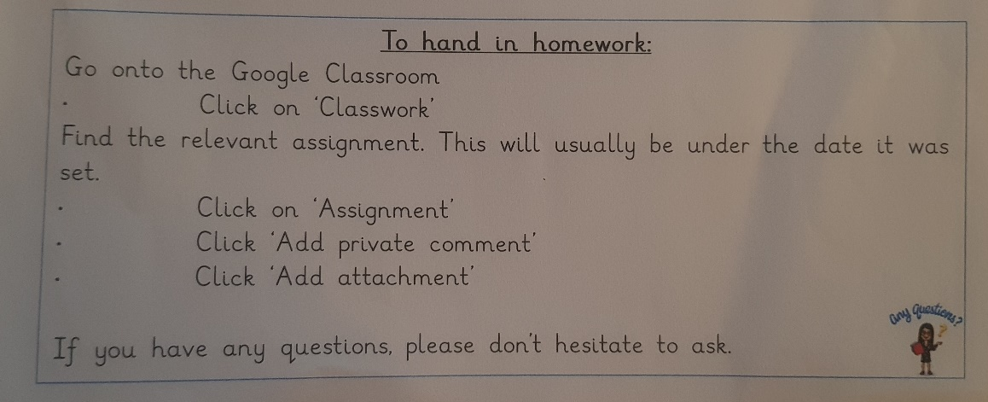

Please remember to click ‘hand in/submit’ once you have uploaded the picture of the homework. Homework is set on Google Classroom on a Wednesday and is to be completed by the following Tuesday. Any problems or if there is any equipment you need for home, please do let me know and I’ll be happy to help!
Google classroom is also where information/ notices/reminders are posted too so don’t forget to check it regularly.

Thanks,
Mrs Hunter

