Mental Health Awareness Week 18th – 24th May 2020
Remember to clap, whistle or bang a saucepan for the NHS and key workers every Thursday to show appreciation for all their hard work.   | Show some kindness to your postie/delivery people and leave a thank you note by your letter box.  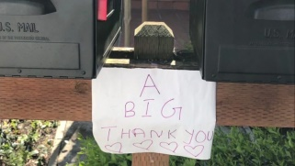 | Do a chore around the house that someone else might usually do.  
Give back to the planet and find a way to re-use one item this week. Maybe you could turn an empty bottle into a bird feeder or plant holder?  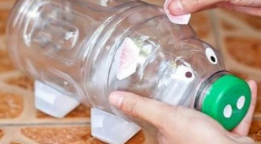 | Write thank you tags what you are grateful for and hang them on a ‘gratitude tree’.  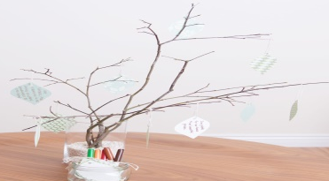 | Start a happiness jar – write down at least one thing every day that has made you happy and pop it in the jar. That way you’ll have some positive memories to look back on at this strange time.  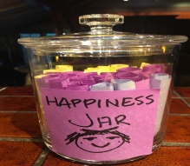
Take a moment to study your reflection and try to find three things that are similar and three things that are different to a friend or family member.   | Try to notice one thing that makes you feel excited and one thing that makes feel calm and relaxed.   | Snuggle up and spend time with your loved ones. Your family is important and special to you.  
Keeping in touch with your family and friends - each day you could ask your parents/carers if you can share your work on FaceTime, WhatsApp etc. Remember to be safe online. You must only talk to people who you know. Grandparents especially will be pleased to hear from you.
Remember to keep washing your hands for 20 seconds – the germs hate it! Hand washing is your Super Power!

