Mental Health Awareness Week 18th – 24th May 2020
Play animal races (hop like a rabbit, slither like a snake, waddle like a duck and so on).  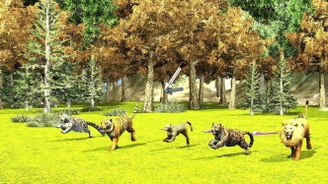 | Throw balls of socks from a distance. Can you improve your aim? Can you improve your distance? Challenge a family member to join in.  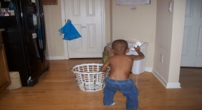 | Create your own quiet space by making a den. Ask an adult what sheets you can use.  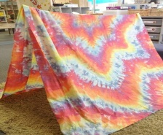
Recreate a scene from your favourite movie or book. Why not film it too?   | Do a quiz with your friends via video call.   | Find out the meaning of your name (and your family’s names too).  
Design and make your own board game and play it with your family.  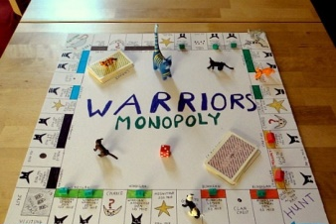 | Do three random acts of kindness in one day.  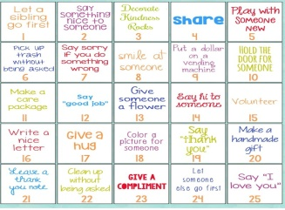 | Draw a thank you picture for your bin collection team and put it on your bin when it is time for them to be collected. Wash your hands!  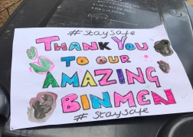
Keeping in touch with your family and friends - each day you could ask your parents/carers if you can share your work on FaceTime, WhatsApp etc. Remember to be safe online. You must only talk to people who you know. Grandparents especially will be pleased to hear from you.
Remember to keep washing your hands for 20 seconds – the germs hate it! Hand washing is your Super Power!

