Mental Health Awareness Week 18th – 24th May 2020
Make and write a happiness card to say thank you or show someone you care.  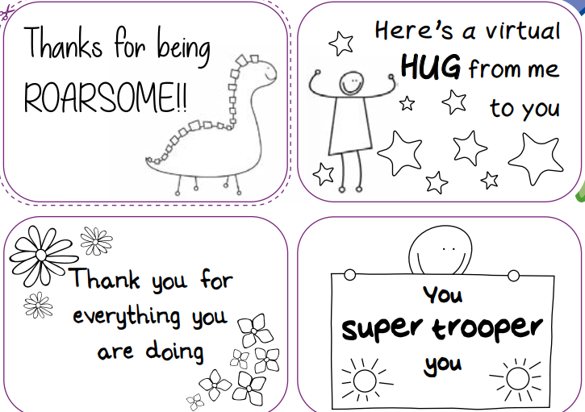 | Think about someone who might be lonely at this time and send happy mail to cheer them up. This could be a picture, a poem, a letter etc. and can be sent in the post, emailed etc.  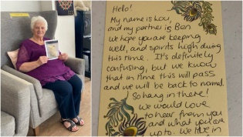 | Make up a new joke and see if you can make your family laugh.  
Find out something about your parents or grandparents that you didn’t already know. You could ask some of these questions: • Where did they go to school? • Where was their first job? • Where did they live when you were first born? • What did they do for fun when they were your age? • When they were your age, what job did they want to do? | Create your close family tree. Why not make it into a poster and make it look creative?  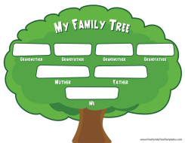 | Invent your own secret code and write messages to your family.  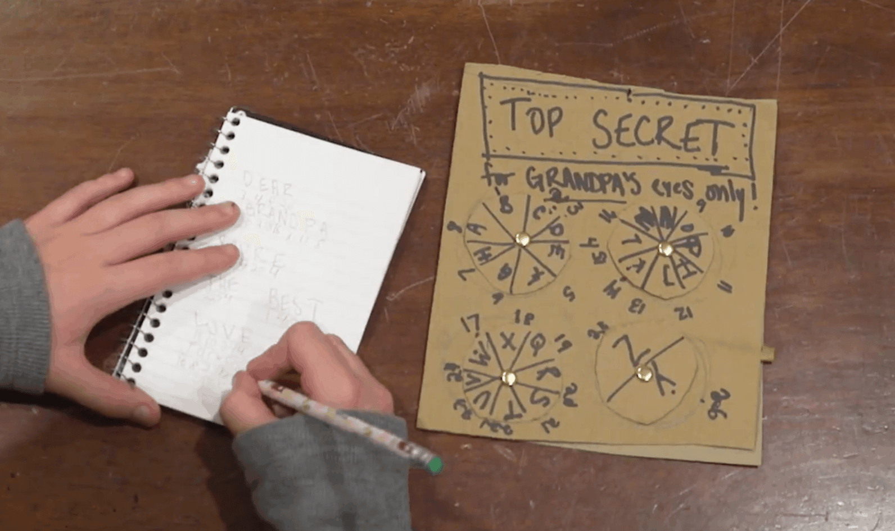
Help round the house - when the laundry is clean, take one item at a time from the dryer or washing line and take it to the room where it belongs and put it away. If you have to go upstairs you should be puffed out by the end of this one! | Put on your favourite music and dance for 10 minutes.   | Try making a giant picture on the floor from household items – ‘Art Attack’ style (remember to tidy up afterwards!).  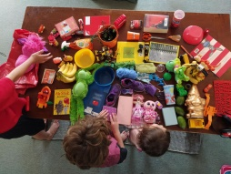
Keeping in touch with your family and friends - each day you could ask your parents/carers if you can share your work on FaceTime, WhatsApp etc. Remember to be safe online. You must only talk to people who you know. Grandparents especially will be pleased to hear from you.
Remember to keep washing your hands for 20 seconds – the germs hate it! Hand washing is your Super Power!

